

**SCHOOL OF PHYSICS**

# UNIVERSITI SAINS MALAYSIA

**ZCT191/192 PHYSICS PRACTICAL I/II**

1EM5 ALTERNATING CURRENT RESONANCE

***Lab Manual***

# OBJECTIVES

1. *To determine the resonant frequency of a series circuit;*
2. *To determine the Q factor and resistance of a series circuit;*
3. *To study the phase difference between the current and applied voltage for a series circuit; and*
4. *To determine the resonant frequency of a parallel resonant circuit.*

# THEORY

### Introduction

The purpose of this experiment is to investigate the characteristics of resonant circuits containing the three basic components in electronics, which are the resistor (𝑅), inductor (𝐿), and capacitor ( 𝐶 ). Whether simple or complicated, most circuits consist of these three components.

The resistance of a pure resistor does not vary with frequency; however inductors and capacitors possess characteristics that depend on frequency, which results in *phase shifts* between the applied voltage and current. When *alternating current* (AC) flows through a resistor, the applied voltage and current are in phase. However, the applied voltage leads the current by ¼ of a cycle (90°) for an inductor, while the current leads the applied voltage by ¼ of a cycle for a capacitor. The presence of 𝑅, 𝐿 and 𝐶 introduces an *impedance* within a circuit.

### RLC Circuits

**Figure 1**: An oscillator connected to an RLC circuit in series.

Consider the 𝑅𝐿𝐶 series circuit in **Figure 1**. When the circuit is supplied with an AC sinusoidal voltage source, the resultant current is an applied voltage as a function of frequency. Using complex notation (see **APPENDIX**), the *impedance* within a circuit is given by

|  |  |
| --- | --- |
| 𝑍 = 𝑅 + 𝑖(𝑋𝑋𝐿 − 𝑋𝑋𝐶), | (1) |

where 𝑅 is the *resistance*, 𝑋𝑋𝐿 = 2𝜋𝐿 the *inductive reactance*, and 𝑋𝑋𝐶 = 1/2𝜋𝐶 the *capacitive reactance*. Thus, the value of *effective current* (𝐼) is

|  |  |
| --- | --- |
| 𝑉 𝑉  𝐼 = = .  𝑍 𝑅 + 𝑖(𝑋𝑋𝐿 − 𝑋𝑋𝐶) | (2) |

The absolute value of 𝐼 can be written as

|  |  |
| --- | --- |
| |𝑉|  |𝐼| = ,  �𝑅2 + (𝑋𝑋𝐿 − 𝑋𝑋𝐶)2 | (3) |

or in frequency terms,

|  |  |
| --- | --- |
| |𝑉|  |𝐼| = .  � 1 2  𝑅2 + (2𝜋𝑓𝐿 − 2𝜋𝑓𝐶) | (4) |

Equation (4) shows that when 𝑓 approaches zero, |𝐼| also approaches zero; when 𝑓 approaches infinity, |𝐼| approaches zero as well. It is thus clear that |𝐼| possess a maximum value at a frequency 𝑓0, and this maximum value occurs when

|  |  |
| --- | --- |
| 1  2𝜋𝑓0𝐿 − 2𝜋𝑓 𝐶 = 0,  0 | (5) |

in which we get the *critical frequency* 𝑓0 as

|  |  |
| --- | --- |
| 1  𝑓0 = .  2𝜋√𝐿𝐶 | (6) |

At this frequency, the current 𝐼 will possess a maximum value of

|  |  |
| --- | --- |
| |𝑉|  |𝐼|0 = 𝑅 , | (7) |

whereas any frequency 𝑓 other than 𝑓0 will result in a current |𝐼| < |𝑉|/𝑅. Qualitatively, the frequency response in such a series circuit is shown in **Figure 2**.

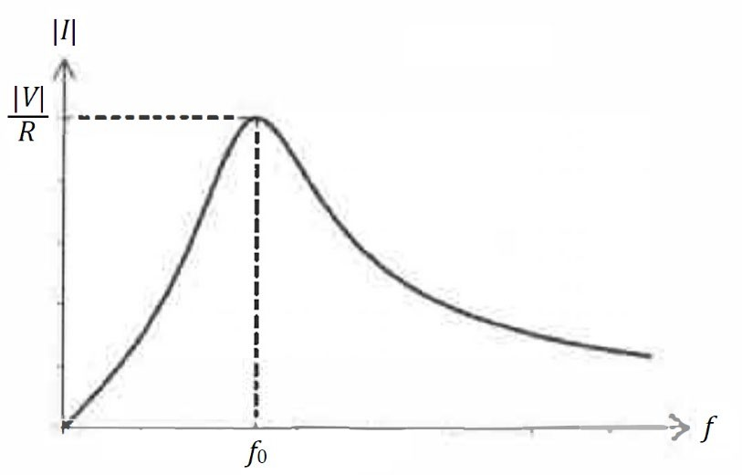

**Figure 2**: Current versus frequency in a series circuit.

Equation (2) can be used to obtain the *phase angle* between the applied voltage and the current. Using the properties of complex conjugates, we get

|  |  |
| --- | --- |
| 𝑉 𝑅 − 𝑖(𝑋𝑋𝐿 − 𝑋𝑋𝐶)  𝐼 =  𝑅 + 𝑖(𝑋𝑋𝐿 − 𝑋𝑋𝐶) 𝑅 − 𝑖(𝑋𝑋𝐿 − 𝑋𝑋𝐶)  𝑉𝑅 − 𝑖𝑉(𝑋𝑋𝐿 − 𝑋𝑋𝐶)  = .  𝑋𝑋𝐿 − 𝑋𝑋𝐶 2  1 + ( 𝑅 ) | (8) |

From this expression, we can see that the phase angle 𝜃𝜃 is

|  |  |
| --- | --- |
| 𝜃𝜃 = tan−1 𝑋𝑋𝐿 − 𝑋𝑋𝐶).  (  𝑅 | (9) |

From equations (6) and (9), when 𝑓 = 𝑓0 and X𝐿 = X𝐶, we get 𝜃𝜃 = tan−1(0) or 𝜃𝜃 = 0, i.e. the applied voltage and resultant current are in the same phase at frequency 𝑓0. This known as the *resonance* condition, where the net impedance is purely resistive. It is found that at resonance, the current is maximum and the impedance is minimum.

### The Q Factor

At resonance, X𝐿 = X𝐶. Using equation (6), we get

1

X = 2𝜋𝑓 𝐿 = 2𝜋 (

) 𝐿 = �𝐿 = X . (10)

𝐿 0

2𝜋√𝐿𝐶

𝐶 0

Thus, it can be shown that at resonance,

|  |  |
| --- | --- |
| X0 1  2𝜋𝐿 = , = 𝑓0X0.  𝑓0 2𝜋𝐶 | (11) |

Inserting equation (11) into equation (4), we get

|  |  |
| --- | --- |
| |𝑉| 1 |𝑉| 1  |𝐼| = = ,  𝑅 𝑅  X 2 𝑓 𝑓 2 𝑓 𝑓 2  �1 + ( 0) ( − 0) �1 + 𝑄𝑄2 ( − 0)  𝑅 𝑓0 𝑓 𝑓0 𝑓 | (12) |

where 𝑄𝑄 = X0/𝑅 is known as the *Q factor* of the circuit. For practical purposes, we can rewrite equation (12) as

|  |  |
| --- | --- |
| |𝐼| 1  |𝐼| = .  0 𝑓 𝑓 2  �1 + 𝑄𝑄2 (𝑓 − 0)  0 𝑓 | (13) |

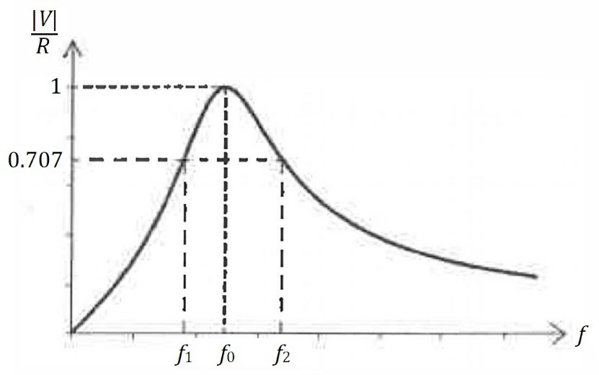

**Figure 3**: Graph of |𝐼|/|𝐼0| versus frequency 𝑓.

The Q factor can be obtained through graphical methods, as shown in **Figure 3**. From the experiment, the Q factor can be determined from the relationship

𝑄𝑄 =

𝑓2

𝑓0

− 𝑓 , (14)

1

where 𝑓1 and 𝑓2 are known as *half-power frequencies*, when the power 𝑃 = 𝑃0/2, or when

|𝐼| = |𝐼0|/√2 = 0.707|𝐼0|.

### Parallel Resonant Circuits

**Figure 4**: A parallel resonant circuit.

When resonance occurs in a *parallel resonant circuit*, the impedance is maximum but the current in the circuit becomes minimum. The resonant frequency (𝑓0) for a parallel circuit as shown in **Figure 4** is

|  |  |
| --- | --- |
| 1 1 𝑅2  𝑓0 = � − 1 . 2𝜋 𝐿𝐶 𝐿2 | (15) |

# PROCEDURE

## Part A: Resonant Frequency of a Series Circuit

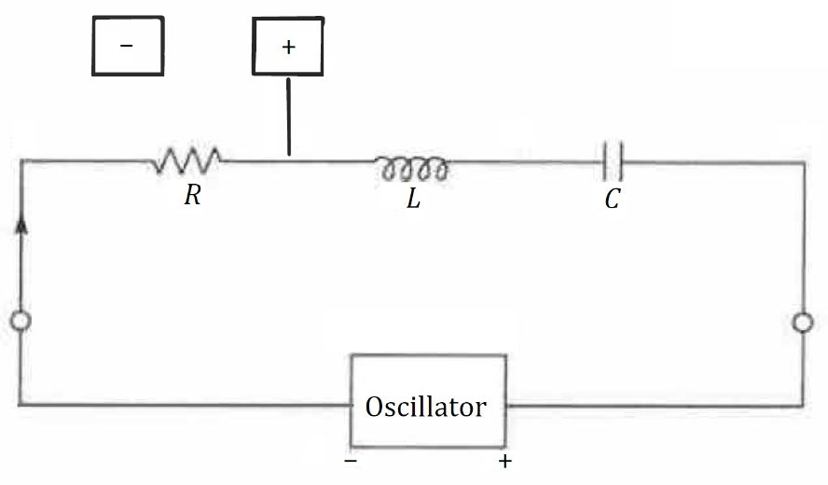

**Figure 5:** Experimental setup for Parts A and B.

### Measurement

1. Connect the circuit as shown in **Figure 5**, using resistors, inductors and capacitors with

𝑅 = 10 kΩ, 𝐿 = 0.5 H and 𝐶 = 2100 pF, respectively.

1. Connect the cathode ray oscilloscope (CRO) across 𝑅.
2. Plot the values of 𝑉𝑅/𝑉𝑅,max against the frequency 𝑓 of the oscillator, where 𝑉𝑅,max is the maximum voltage value across 𝑅.
3. Determine the resonant frequency 𝑓0 from the plot.
4. Compare this value of 𝑓0 obtained with the value obtained from theory.

## Part B: The Q Factor

### Measurement

1. Connect the circuit as shown in **Figure 5** using the same values of 𝐿 and 𝐶 as in **Part A**, but replace 𝑅 with values of 12 kΩ and 8 kΩ.
2. Plot 𝑉𝑅/𝑉𝑅,max against the corresponding frequencies 𝑓 and determine the values of 𝑄𝑄 for the two values of 𝑅 used.
3. Compare the values of 𝑄𝑄 you obtained in the experiment with the values obtained from

theory.

1. Show how 𝑄𝑄 varies with 𝑅 graphically.

## Part C: The Phase Difference between Current and Applied Voltage

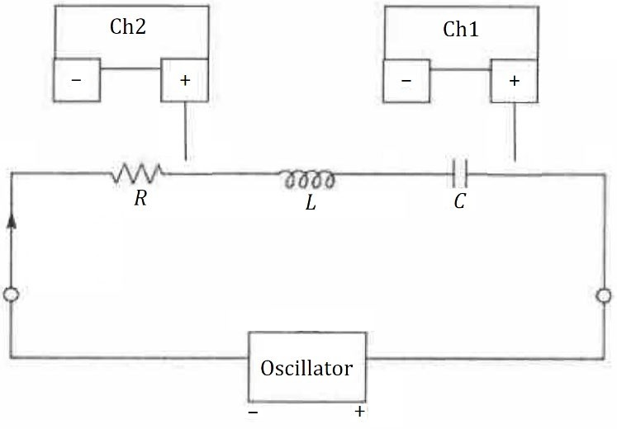

**Figure 6:** Experimental setup for Part C.

### Measurement

1. Connect the circuit as shown in **Figure 6** using the same values of 𝐿 and 𝐶 as in **Part A**, but replace 𝑅 with a value of 800 Ω.
2. Using the CRO with an oscillator frequency 𝑓 given by your lecturer-in-charge, measure the voltage across 𝑅, 𝐿 and 𝐶 using the X-plate.
3. Measure the voltage across 𝑅 using the Y-plate.
4. Draw the Lissajous curve obtained, and determine the phase angle for the circuit.
5. Compare the phase angle obtained from the experiment with the value obtained from theory.
6. Starting with 𝑓 = 0 Hz , increase 𝑓 until it reaches maximum ( ∞ ), and discuss what happens there.

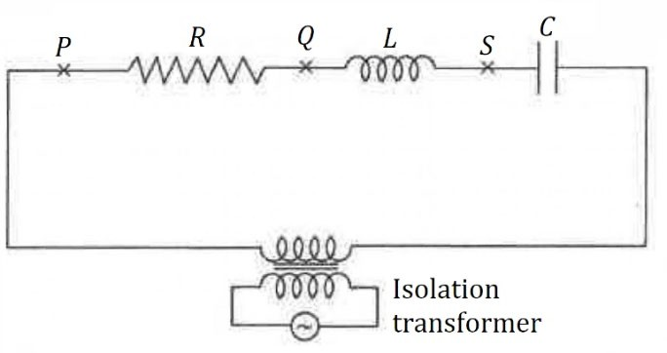

**Figure 7**: A circuit with an isolation transformer.

1. Connect the isolation transformer (**Figure 7**) to the signal source in order to isolate the ground of the supply with the ground of the oscilloscope.
2. Set the signal frequency to 3.8 kHz, and use the value of 𝑅 = 10 kΩ.
3. Connect one end of the oscilloscope earth to point 𝑄𝑄.
4. Connect the oscilloscope Y (**Channel 2**) to 𝑃 and the oscilloscope X (**Channel 1**) to point

𝑆 (between 𝐿 and 𝐶).

1. Obtain the trace and sketch it in your report.
2. Set the display to XY, and obtain the phase between the two signals in the Lissajous curve.
3. Connect the scope ground to 𝑃, **Channel 2** to 𝑄𝑄 and **Channel 1** to 𝑆.
4. From the Lissajous curve shown, obtain the phase angle, and compare this to the value obtained from theory.
5. Now interchange 𝐿 and 𝐶, then repeat **Steps 9** to **14**.
6. From the phase angles obtained in **Steps 13** and **15**, determine which phase leads and which phase lags the signal.

## Part D: Resonant Frequency of a Parallel Circuit

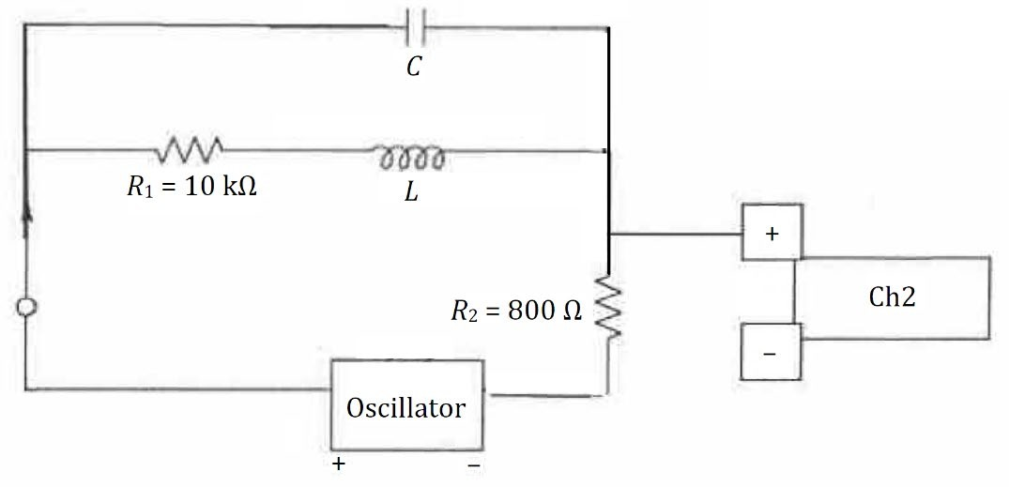

**Figure 8**: Experimental setup for Part D.

### Measurement

1. Connect the circuit as shown in **Figure 8**.
2. Connect the Y-plate of the CRT across 𝑅2, and measure its voltage.
3. Plot 𝑉𝑅2 versus the oscillator frequency, and determine the resonant frequency of the circuit.
4. Compare the value of 𝑓0 obtained from experiment with the value obtained from theory.

# REFERENCES

1. Halliday, D., Resnick, R. & Walker, J. (2020) *Principles of Physics (11th ed.)*. Wiley.
2. Korneff, T. (1966). *Introduction to Electronics (1st ed.)*. Academic Press.
3. Brophy, J. J. (1990). *Basic Electronics for Scientists*. McGraw-Hill.
4. Mitchell, F. H. (1969). *Essentials of Electronics*. Addison-Wesley.

# ACKNOWLEDGEMENT

The original creator of this lab manual is unknown. This manual was revised and standardised by *Dr. John Soo Yue Han* in 2021.

# APPENDIX

### The Complex Plane

The *complex plane* is widely used in studying AC circuits, where vectors are pictured in components along a *real axis* and an *imaginary axis*. Components along the imaginary axis is multiplied with the complex number 𝑖 where 𝑖2 = −1. For example, a current 𝐼 = 4 + 3𝑖 can be visualised in **Figure 9** below.

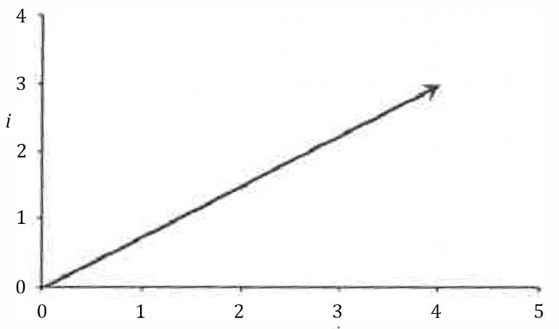

**Figure 9**: The vector 𝐼 = 4 + 3𝑖 in the complex plane.

A *complex conjugate* of a complex quantity must be defined to obtain its *absolute value*. The complex conjugate of 𝐼 = 4 + 3𝑖 is 𝐼∗ = 4 − 3𝑖, and the absolute value of 𝐼 is therefore

|  |  |
| --- | --- |
| |𝐼| = √𝐼𝐼∗  = �(4 + 3𝑗𝑗)(4 − 3𝑗𝑗)  = √16 + 9  = √25  = 5. | (16) |

The angle 𝜃𝜃 between 𝐼 and the real axis is defined as tan 𝜃𝜃 = Im(𝐼)/Re(𝐼), where Im and Re refers to the imaginary and real components of 𝐼. Thus, the angle 𝜃𝜃 for the same number 4 + 3𝑖 above is

|  |  |
| --- | --- |
| Im(𝐼) 3  tan 𝜃𝜃 = = Re(𝐼) 4 | (17) |

### Complex Impedance

In the complex plane, resistance is pictured on the real axis, inductive reactance is pictured in the +𝑖 direction on the imaginary axis, while the capacitive reactance is pictured in the −𝑖 direction on the imaginary axis. For example, we consider the current 𝐼 in the phasor circuit shown in **Figure 10** below.

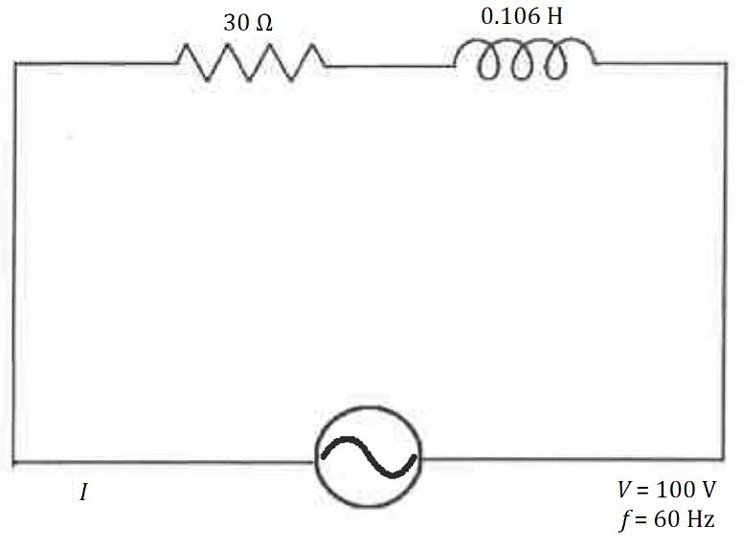

**Figure 10**: Example of a phasor circuit.

The total impedance of the circuit above is 𝑍 = 𝑅 + 𝑖X𝐿 = 30 + 𝑖2𝜋𝑓𝐿 = 30 + 39.96𝑖. The complex current is therefore

|  |  |
| --- | --- |
| 𝑉 100 100 30 − 39.96𝑖  𝐼 = = = = 1.2 − 1.6𝑖,  𝑍 30 + 39.96𝑖 30 + 39.96𝑖 30 − 39.96𝑖 | (18) |

and the absolute value of the current is therefore |𝐼| = √𝐼𝐼∗ = 2 A.

To the draw the phasor diagram, we need to calculate the values of 𝑉R and 𝑉L,

|  |  |
| --- | --- |
| 𝑉R = 𝐼𝑅 = 36 − 48𝑖,  𝑉L = 𝐼(𝑖XL) = (1.2 − 1.6𝑖)(40𝑖) = 64 + 48𝑖. | (19)  (20) |

The values of 𝑉𝑅 and 𝑉𝐿 are visualised in the phasor diagram as shown in **Figure 11**.

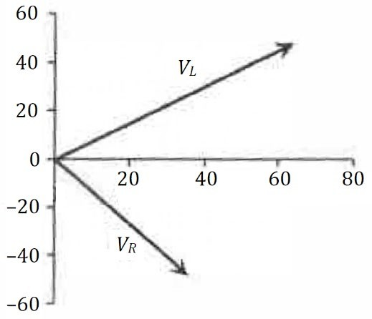

**Figure 11**: Representation of 𝑉𝑅 and 𝑉𝐿 on the complex plane.

*Last updated*: 13 September 2021 (JSYH)